Name: Annie Mahajan Registration No.: 23BRS1121

Lab – 04

Example

import numpy as np

import pandas as pd

from sklearn.datasets import load_iris

from sklearn.model_selection import train_test_split

from sklearn.tree import DecisionTreeClassifier, plot_tree

from sklearn.metrics import accuracy_score, confusion_matrix

import matplotlib.pyplot as plt

iris = load_iris()

X = iris.data

y = iris.target

print("Feature names:", iris.feature_names)

print("Target classes:", iris.target_names)

print("Shape of X:", X.shape)

X_train, X_test, y_train, y_test = train_test_split(

X, y, test_size=0.3, random_state=42

)

# ----- ID3 TREE (Entropy) -----

dt_entropy = DecisionTreeClassifier(criterion='entropy', max_depth=3)

dt_entropy.fit(X_train, y_train)

y_pred_entropy = dt_entropy.predict(X_test)

print("Entropy Accuracy:", accuracy_score(y_test, y_pred_entropy))

plt.figure(figsize=(12,6))

plot_tree(dt_entropy,

feature_names=iris.feature_names,

class_names=iris.target_names,

filled=True)

plt.show()

# ----- CART TREE (Gini) -----

dt_gini = DecisionTreeClassifier(criterion='gini', max_depth=3)

dt_gini.fit(X_train, y_train)

y_pred = dt_gini.predict(X_test)

print("Accuracy:", accuracy_score(y_test, y_pred))

print("Confusion Matrix:\n", confusion_matrix(y_test, y_pred))

plt.figure(figsize=(12,6))

plot_tree(dt_gini,

feature_names=iris.feature_names,

class_names=iris.target_names,

filled=True)

plt.show()
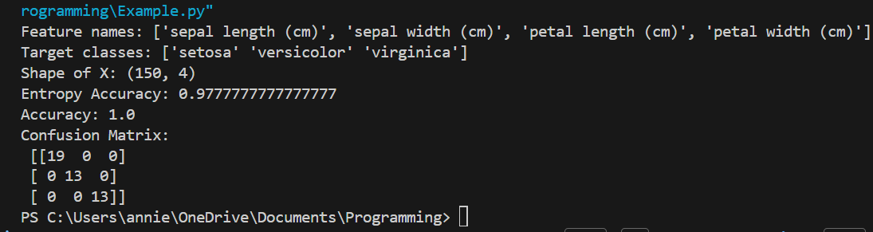
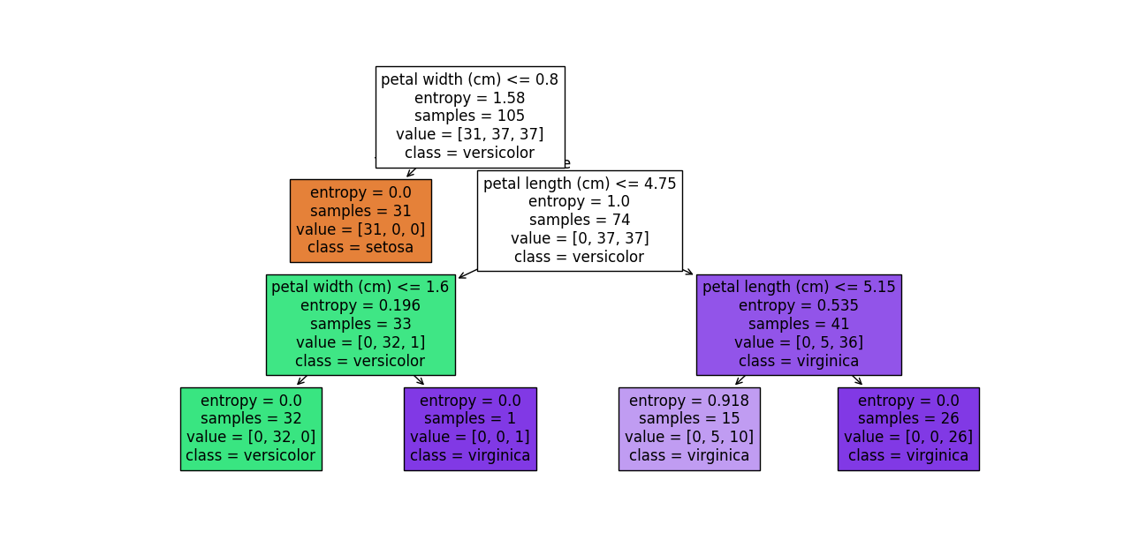

Exercise 1

import pandas as pd
import seaborn as sns
import matplotlib.pyplot as plt
df = sns.load_dataset('titanic')
print(df.head())
print("\nMissing values:\n", df.isna().sum())
before = df.isna().sum()
plt.figure(figsize=(10,5))
before.plot(kind='bar')
plt.title("Missing Values Before Handling")
plt.ylabel("Count")
plt.show()
plt.figure(figsize=(12,4))
sns.heatmap(df.isna(), cbar=False)
plt.title("Heatmap Before Handling Missing Data")
plt.show()
df_filled = df.copy()
# Age – Median Imputation
df_filled['age'].fillna(df_filled['age'].median(), inplace=True)
# Cabin – Fill with “Unknown”
df_filled['deck'].fillna("Unknown", inplace=True)
# Embarked – Remove rows
df_filled.dropna(subset=['embarked'], inplace=True)
print("\nAfter Handling:\n", df_filled.isna().sum())
after = df_filled.isna().sum()
comparison = pd.DataFrame({'Before': before, 'After': after})
comparison.plot(kind='bar', figsize=(10,5))
plt.ylabel('Number of missing values')
plt.title('Missing Values: Before vs After Imputation')
plt.show()
sns.heatmap(df_filled.isna(), cbar=False)
plt.title("After Handling Missing Data")
plt.show()
# Histogram Visualization
plt.figure(figsize=(8,4))
df['age'].hist(alpha=0.5, bins=20, label='Before')
df_filled['age'].hist(alpha=0.5, bins=20, label='After')
plt.legend()
plt.title('Age Distribution Before vs After Imputation')
plt.show()

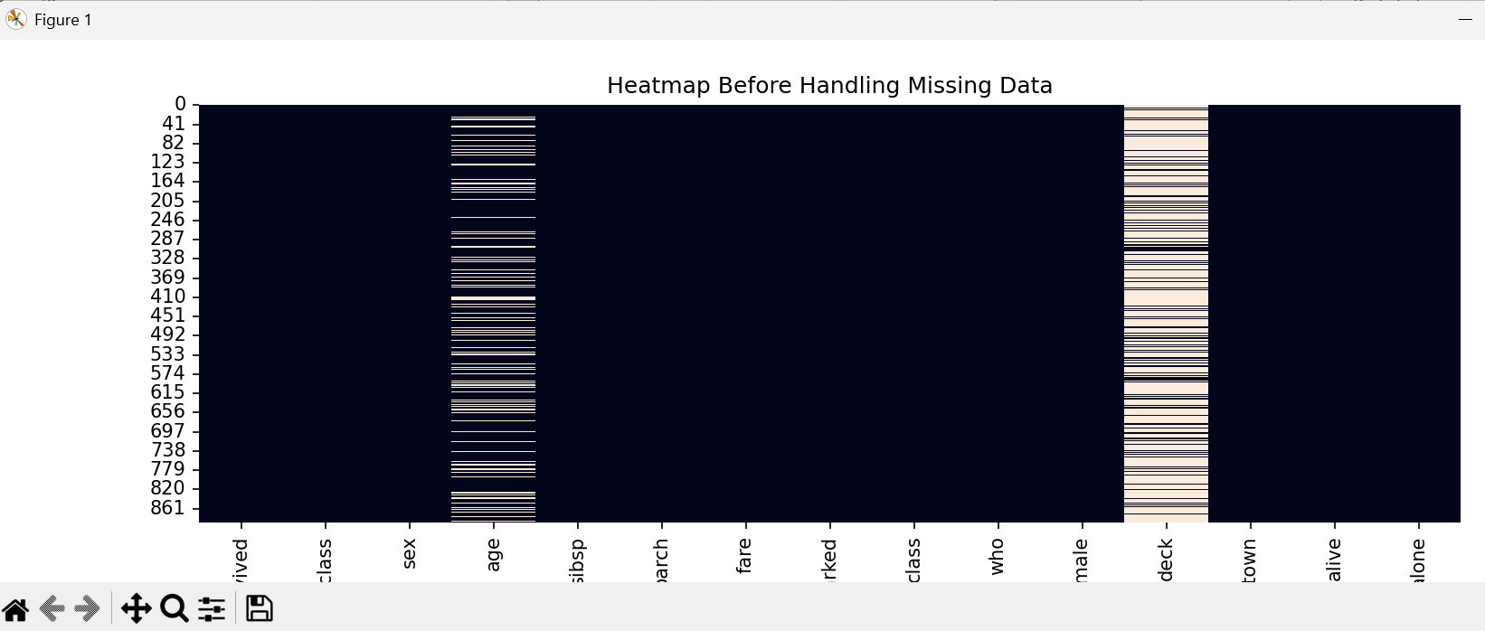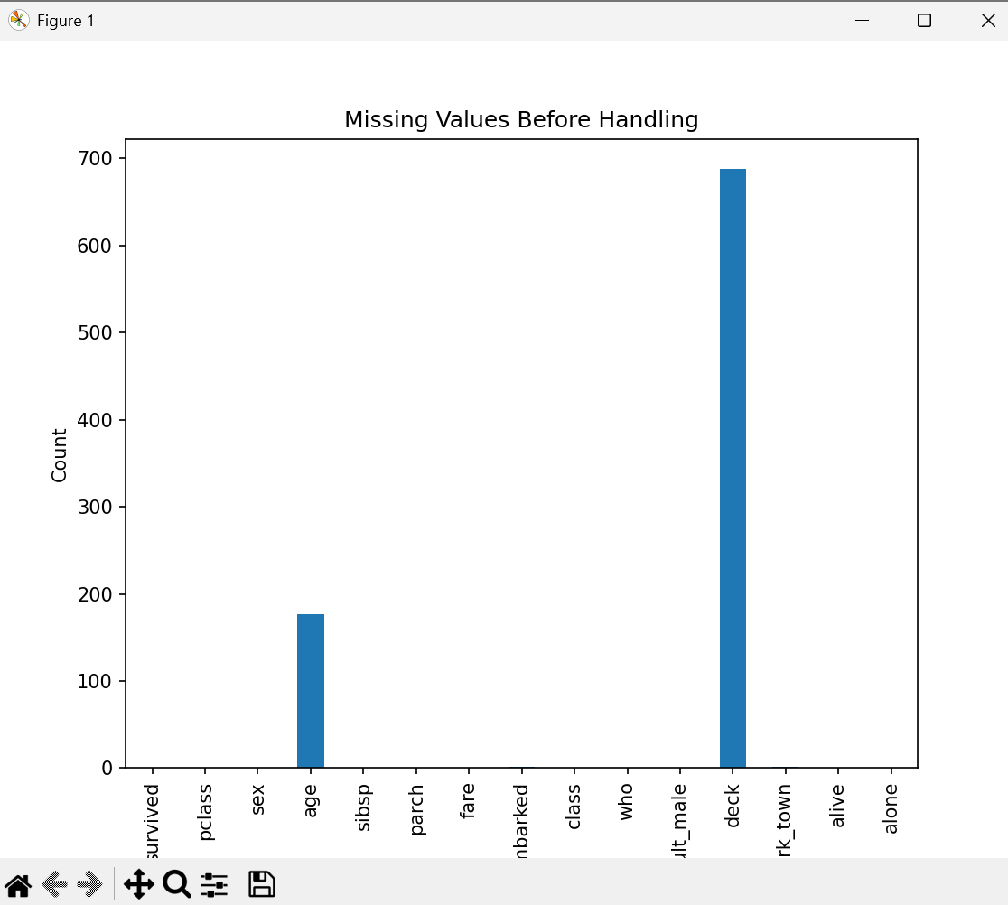
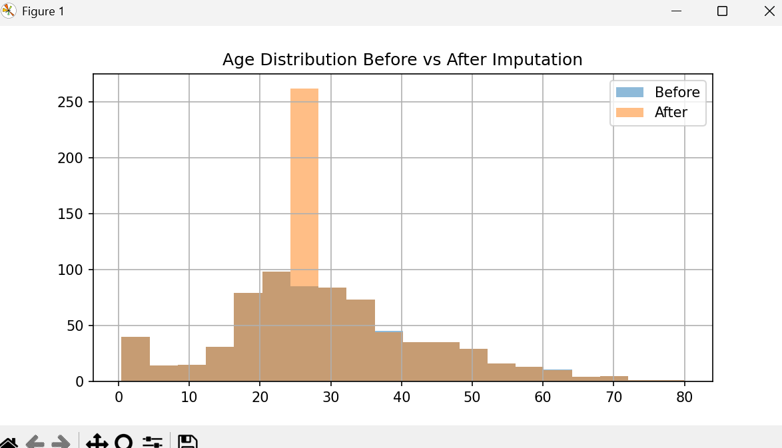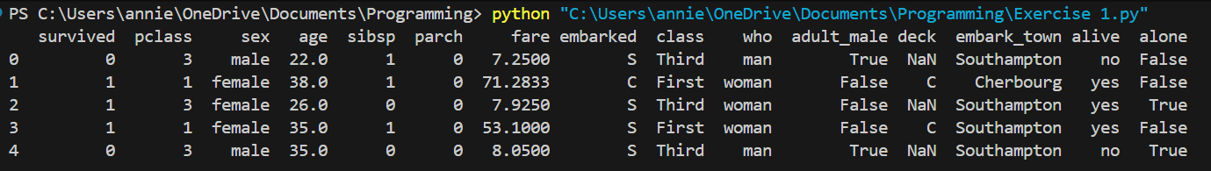
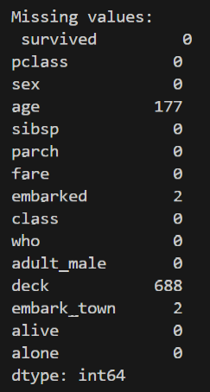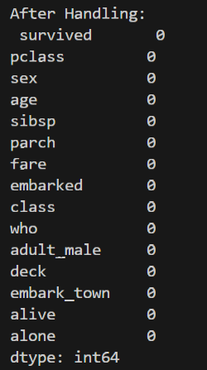

Exercise 2

import pandas as pd
import seaborn as sns
import matplotlib.pyplot as plt
from sklearn.preprocessing import LabelEncoder
from sklearn.model_selection import train_test_split
from sklearn.tree import DecisionTreeClassifier
from sklearn.tree import plot_tree
# Load and prepare data
df = sns.load_dataset('titanic')
df_filled = df.copy()
df_filled['age'] = df_filled['age'].fillna(df_filled['age'].median())
df_filled['deck'] = df_filled['deck'].astype('object').fillna("Unknown")
df_filled.dropna(subset=['embarked'], inplace=True)
data = df_filled[['survived','pclass','age','fare','sex']]
le = LabelEncoder()
data['sex'] = le.fit_transform(data['sex'])
X = data.drop('survived', axis=1)
y = data['survived']
X_train, X_test, y_train, y_test = train_test_split(
X, y, test_size=0.3, random_state=42
)
depths = [1,2,3,4,5,6,7,8,9,10]
for d in depths:
model = DecisionTreeClassifier(max_depth=d, random_state=42)
model.fit(X_train, y_train)
train_acc = model.score(X_train, y_train)
test_acc = model.score(X_test, y_test)
print(f"Depth={d}, Train Acc={train_acc:.2f}, Test Acc={test_acc:.2f}")
best_model = DecisionTreeClassifier(max_depth=3, random_state=42)
best_model.fit(X_train, y_train)
plt.figure(figsize=(12,6))
plot_tree(best_model,
feature_names=X.columns,
class_names=['Not Survived','Survived'],
filled=True)
plt.show()
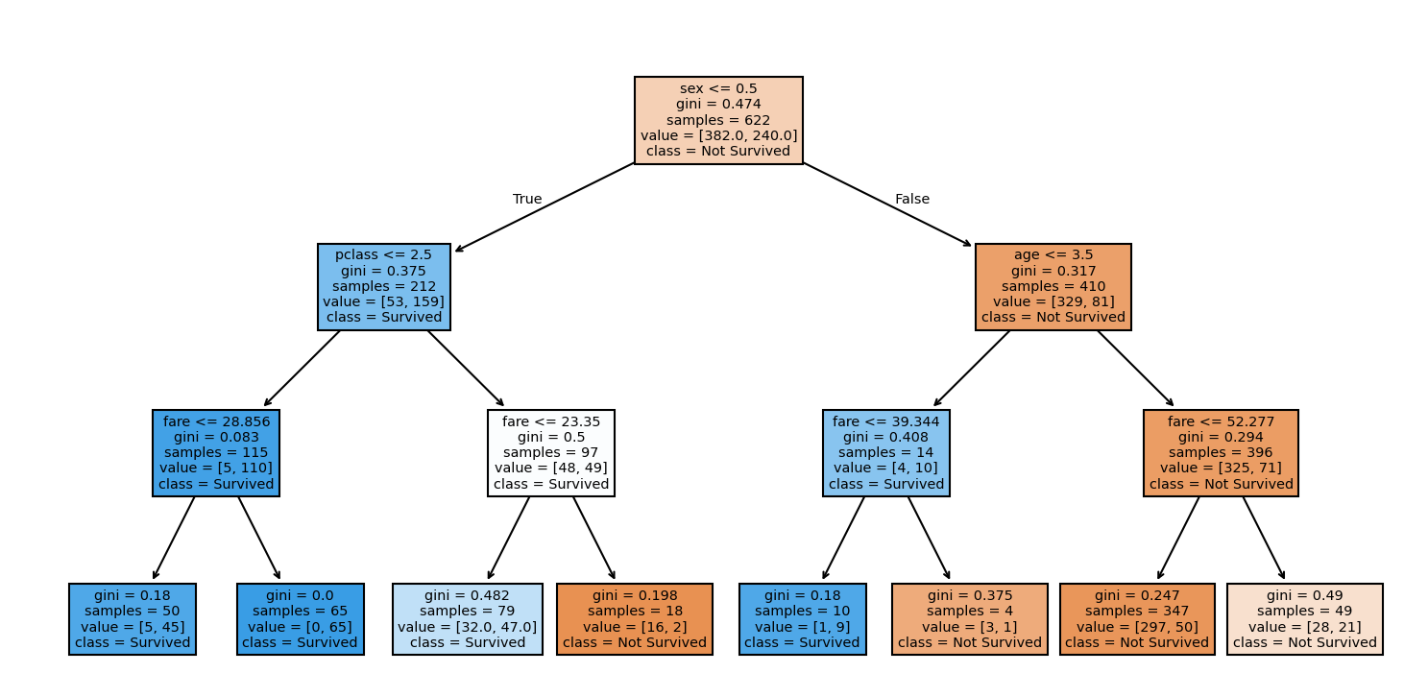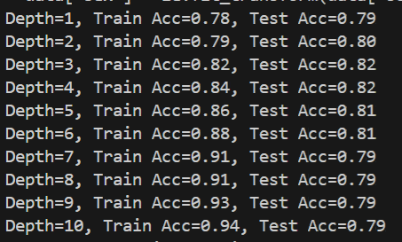

Exercise 3

from sklearn.metrics import accuracy_score
clf = DecisionTreeClassifier(random_state=42)
clf.fit(X_train, y_train)
path = clf.cost_complexity_pruning_path(X_train, y_train)
ccp_alphas = path.ccp_alphas
train_acc = []
test_acc = []
for alpha in ccp_alphas:
clf_alpha = DecisionTreeClassifier(random_state=42, ccp_alpha=alpha)
clf_alpha.fit(X_train, y_train)
train_acc.append(accuracy_score(y_train, clf_alpha.predict(X_train)))
test_acc.append(accuracy_score(y_test, clf_alpha.predict(X_test)))
plt.figure(figsize=(8,5))
plt.plot(ccp_alphas, train_acc, marker='o', label='Train Accuracy')
plt.plot(ccp_alphas, test_acc, marker='s', label='Test Accuracy')
plt.xlabel('ccp_alpha')
plt.ylabel('Accuracy')
plt.title('Post-Pruning on Titanic Dataset')
plt.legend()
plt.grid(True)
plt.show()
best_alpha = ccp_alphas[test_acc.index(max(test_acc))]
clf_pruned = DecisionTreeClassifier(random_state=42, ccp_alpha=best_alpha)
clf_pruned.fit(X_train, y_train)
print("Best ccp_alpha:", best_alpha)
print("Test Accuracy (pruned tree):",
accuracy_score(y_test, clf_pruned.predict(X_test)))
plt.figure(figsize=(12,6))
plot_tree(clf_pruned,
feature_names=X.columns,
class_names=['Not Survived','Survived'],
filled=True)
plt.show()

